**DSA Assignment – 14th July**

**Name – Karan Joshi**

**Roll No. – 23/11/EC/036**

**Leetcode Id – Karan_Joshi068048**

**Geeksforgeeks Id – wwwjoshikaran3424**

**Github Repo Link -** [**https://github.com/KaranJoshi101/urban-octo-robot/**](https://github.com/KaranJoshi101/urban-octo-robot/)

DSA-Section -

Question 1: Inorder Traversal

Platform: LeetCode

Problem Link: <https://leetcode.com/problems/binary-tree-inorder-traversal/description/>

Submission Screenshot:

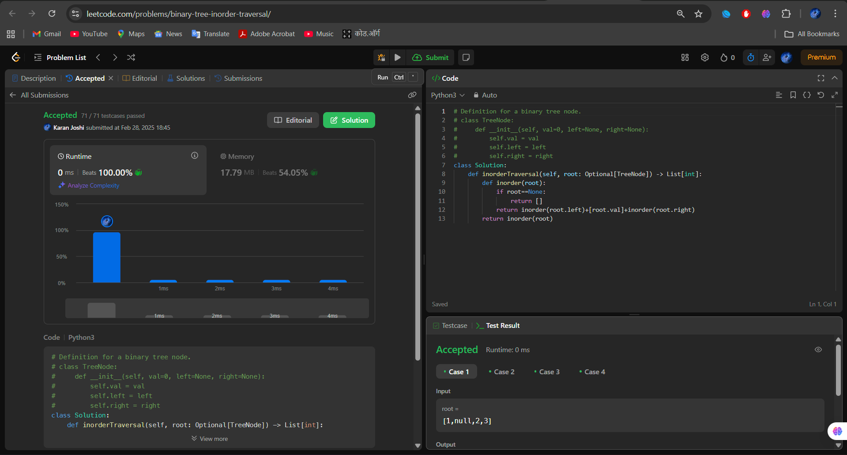

Question 2: Level Order Traversal

Platform: LeetCode

Problem Link: Binary Tree Level Order Traversal – LeetCode

Submission Screenshot:

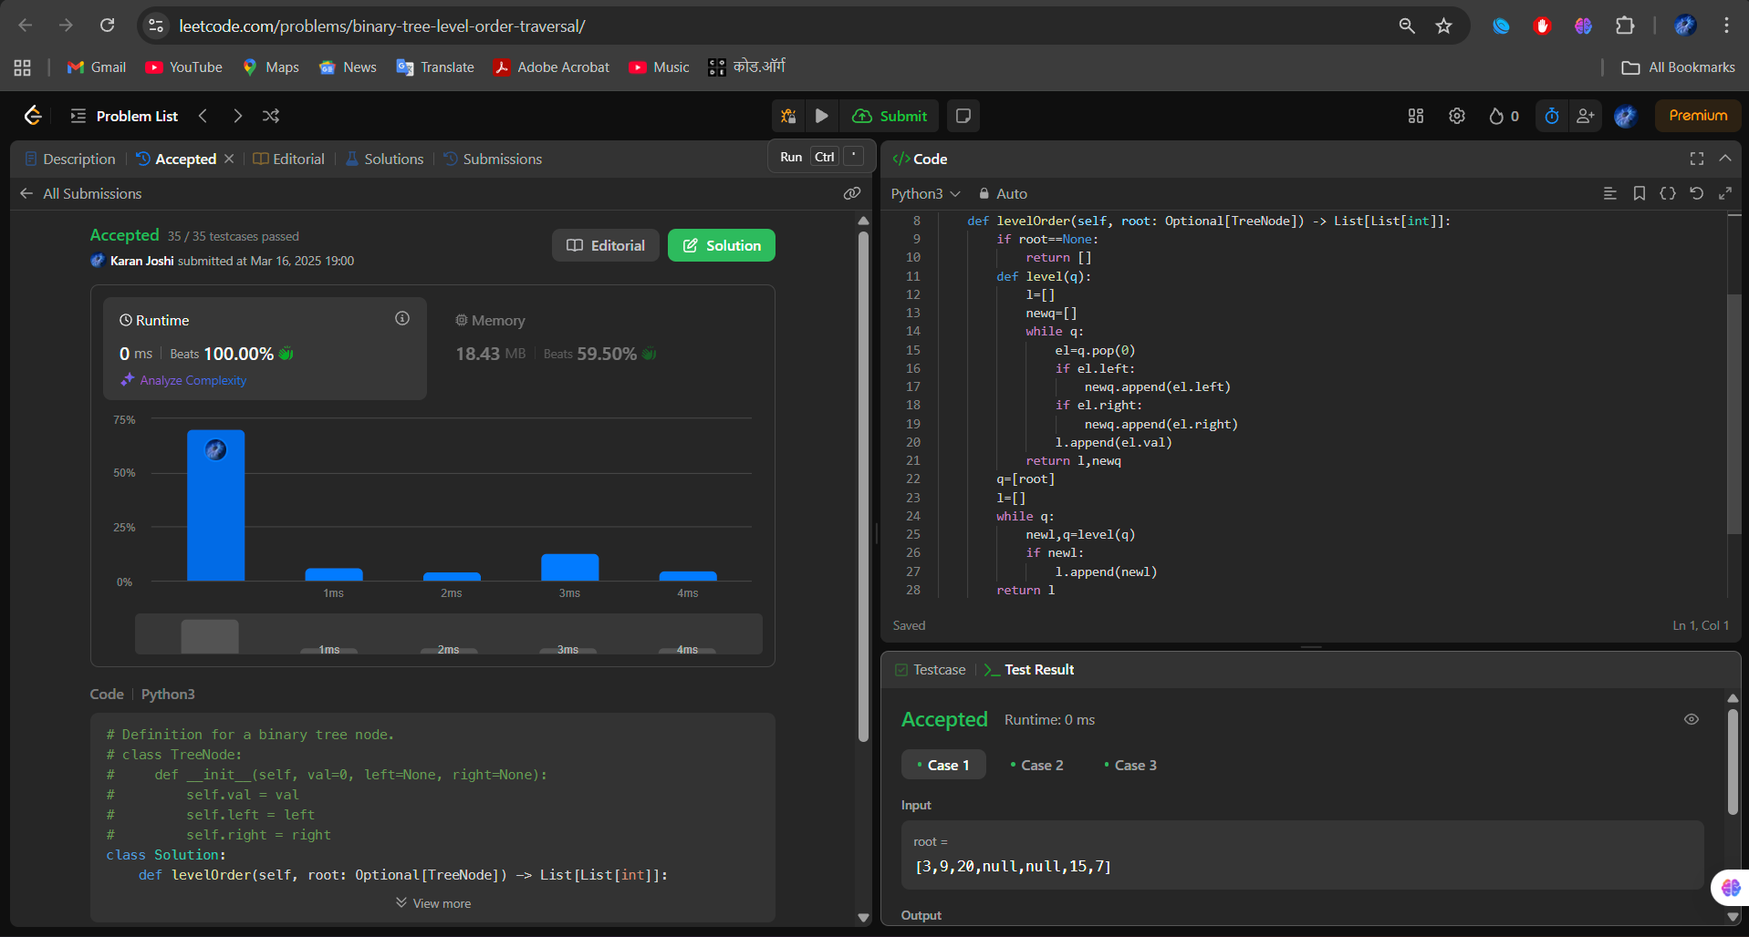

Question 3: Maximum of Binary Tree

Platform: LeetCode

Problem Link: Maximum Depth of Binary Tree – LeetCode

Submission Screenshot:

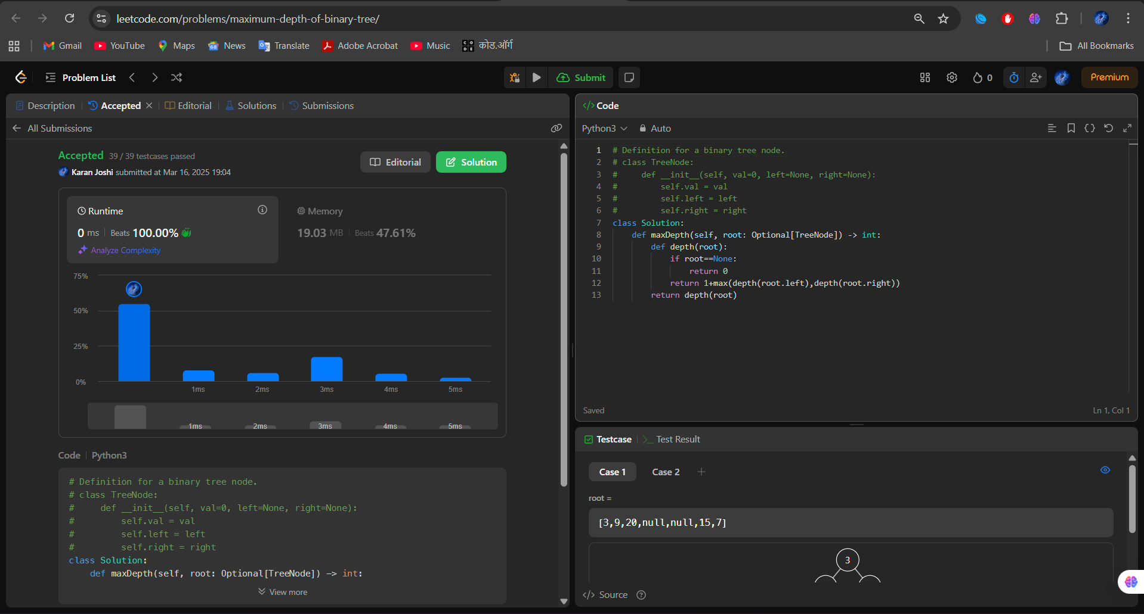

Question 4: Diameter of Binary Tree

Platform: LeetCode

Problem Link: Diameter of Binary Tree – LeetCode

Submission Screenshot:

